OCR GCE A Level

COMPUTER SCIENCE PROJECT

H446-03
Name: Filips Reisons
College ID: 20221892

Monoux College: 13425
Candidate Number: <INSERT CANDIDATE NUMBER>

Title of Project: The hunt for Blue November
Date of Project: 16/11/22
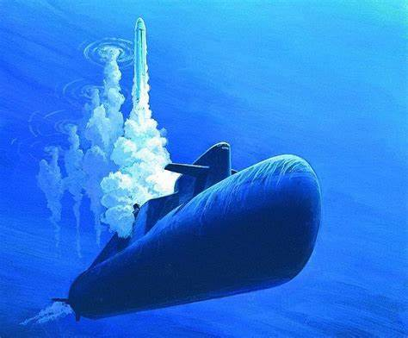

Table of Contents
Analysis of the problem 3
3.1.1 Problem 3
project identification / statement 3
project definition 3
3.1.2 Stakeholders 4
General audience 4
Mr Luft 4
me 4
someone else? 4
3.1.3 Computational Thinking 4
Thinking abstractly 4
Thinking ahead 5
Thinking procedurally 5
Thinking logically 5
Thinking concurrently 5
3.1.4 Research 5
Red storm rising (1988) 6
silent hunter 1 (1996) 7
cold waters (2016) 10
3.1.5 Requirements 11
Essential features 11
Limitations 11
Hardware and Software 11
Success criteria 11
B. Design of the solution 12
3.2.1 Decompose the problem 12
structure 12
step by step 12
3.2.2 Describe the solution 16
Algorithms 16
Usability 17
Variables 17
3.2.3 Describe the approach to testing 17
milestones 17
test data 17
Testing during implementation 17
Testing post-production 17
Systems diagram 17
C. Developing the coded solution (“The development story”) 17
3.3.1 Iterative development process 17
3.3.2 Testing to inform development 17
D. Evaluation 17
3.4.1 Testing to inform evaluation 17
3.4.2 Success of the solution 18
3.4.3 Describe the final product 18
3.4.4 Maintenance and development 18
Project Appendixes 18
Sources 18

Analysis of the problem

3.1.1 Problem

project identification / statement
For my project I am planning to create a game akin to older submarine simulation games such as 1988’s Red storm rising and 1996’s Silent hunter 1. In these games you control a submarine which you use to attack enemy ships and submarines with torpedoes and missiles while evading detection. They are single player against ai enemies which search for you and attack you with depth charges and torpedoes. To win a mission, you must defeat all enemies without losing all your health and subsequently being defeated. As these games are a part of the simulation genre, they are quite in depth and feature realism unlike a more arcade type game.

project definition
For my project I hope to produce a game where the player will control a submarine, using it and its weapons to destroy enemy ships that will be trying to destroy the player. This will occur in real time, with the player controlling direction, speed, depth and weapon employment through text commands from a given list. To inform the player’s choices, there will be a map of the submarine’s surroundings marked with all detected enemies and incoming weapons. The player will be destroyed after being hit by a guided enemy weapon, if I add a difficulty setting then this could be changed. There are no levels, on start of a new game enemies will be randomly placed and once they are all defeated the player will gain score and the option to play another match.
Features: A map with detected entities; A text box for inputting commands; indicators for depth, speed, bearing

3.1.2 Stakeholders

General audience
The game will not be fast paced or graphically impressive, but will be tense and have complexity and require tactical thinking, so I am targeting an older audience of around 16 and above as younger audiences may not be as interested. It will interest people that have interests in naval warfare. It will run on a computer using a keyboard mostly and possibly the mouse for interacting with limited gui, which could make the game more difficult to play as it may not be possible to rely on buttons and on-screen items alone. It also requires the time investment of sitting down at a computer to play so isn’t as convenient as a mobile game meaning it will be played less often but for longer sessions.

Zahid - Classmate
Zahid is a computer science student in the same class as me. He’s in the target age range and enjoys playing horror games. While my game isn’t a horror game, it does have themes of horror and I think I would benefit from having a point of view that differs from my own.

Interview 2/10/24
I’m making a game that involves controlling a submarine to destroy enemy ships. Do you have any experience or familiarity with media that relates to ocean vessels?
“I’ve played Man of Medan where there’s a group of survivors on an abandoned ship where the main goal is to get through the game and make it out alive, I’ve also watched a story based on Man of Medan called “The Ourang Medan” about a shipwreck in the Dutch east indies, both of them lean into themes of horror”
So you’d like to have the game evoke feelings of fear and terror?
“As a fan of horror games and movies, I like media that portrays suspense, terror and tension.”
How do you think I should invoke these feelings?
“Dark colours, a limited view of what’s around you, and sound design”

Personal desires
I am a stakeholder because I loved reading Red storm rising and want to see a game inspired by it despite that game already existing. I am also quite interested in military hardware and vehicles, and how for each new generation of vehicles an increasing number of considerations must be made to keep them up to date and combat effectively against their adversaries. Submarines are incredibly complex and if I would like to create a fully true to life game, I could spend years adding countless complex systems without ever running out of things to consider, develop and program.

3.1.3 Computational Thinking
This problem is well suited for a computer because it can be solved via computational methods. This is because it is easily abstracted to algorithms that are run on a given set of values repetitively to drive the actions of enemies while taking input from the player to drive their own actions.

Thinking abstractly
I have many ideas for features I want to add, but if I try to add them all I will inevitably fail. I need to separate only the features necessary for the game so that I can make an initial working build before adding any complex systems and features to increase realism. These necessary features include:
- One enemy type
- One weapon type
- A map so the player knows what’s around them
- A file containing information on every active entity
- An algorithm to make the enemy do things
- An algorithm to make weapons home in on their targets
- An input method for the player
- A cycle that runs algorithms while the player makes decisions to make it real-time

Thinking ahead
This is a way look into the future and get ideas and a structure down before starting anything so that the goals are clear.
- I will use python in combination with pygame as I am familiar with python and pygame is the most popular and well supported engine for it
- Inputs will be through text-based commands or key inputs
- Outputs will come as objects on the map and text outputs
- The player could receive a medal depending on how they perform

Thinking procedurally
For the code, I will need a system for where every second that passes in game, each enemy vehicle and guided weapon moves in a direction with a speed of its choosing determined by its ai. As all enemy entities of the same type e.g., ships would share the same ai, I will simply have to run each active entity through the ai to get it to determine its own course of action. The game is broken down into:
- Accepting player inputs
- Tracking entity locations
- Algorithms for enemy and weapon ai
- Displaying entity locations

Thinking logically
The player doesn’t require every piece of information available to them. All they need is a general sense of where their enemies are located, their bearing, speed and depth. Limiting the information they receive will reduce their workload and keep players from becoming overwhelmed.
My code will have to run many checks a second to see if hits are scored, if a complete miss occurred, if the enemy ai should reconsider its actions, etc.

Thinking concurrently
Ideally, in-game time would pass in real time, but I may have to compromise where time only passes when the player requests it through a wait command e.g., wait 300 (seconds). There will be no second player to simultaneously process but the game will have to continue running in the background while the player makes decisions and inputs.

3.1.4 Research

Red storm rising (1988)
In 1988, MicroProse released “Red storm rising”, a game based off the book with the same name released two years prior. It is a simulation game that features semi-realistic submarine combat that very much resembles the source material which I have read. In the game, you control a nuclear submarine armed with various weapons for you to engage enemy ships, submarines, and transport ships across the ocean. You identify enemy vessels, fire at them, and in turn you evade detection and avoid enemy weapons. The concept is simple, yet in practise can be incredibly challenging.
My initial inspiration for the project was the book red storm rising, which means the game includes many things I want to include already. Due to this similarity, I want to use the game as a tool to compare and see how features can be done better. As I have not had a chance to fully explore the game yet, I am yet to decide what extra features I would like to take away from the game.
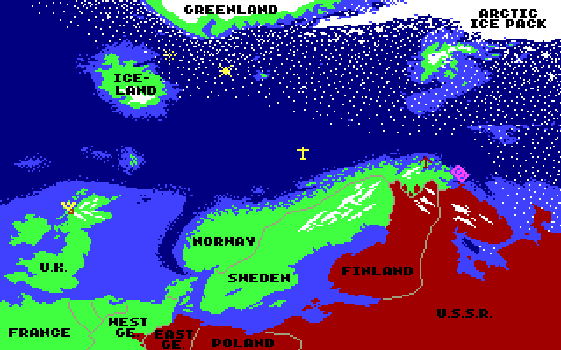
The above screen is a world map that allows players to move between different environments. While it would be a very good feature to add, it is much beyond the scope of what I am able to do as so many variables change between locations and it would require a reason for players to travel, such as a storyline.
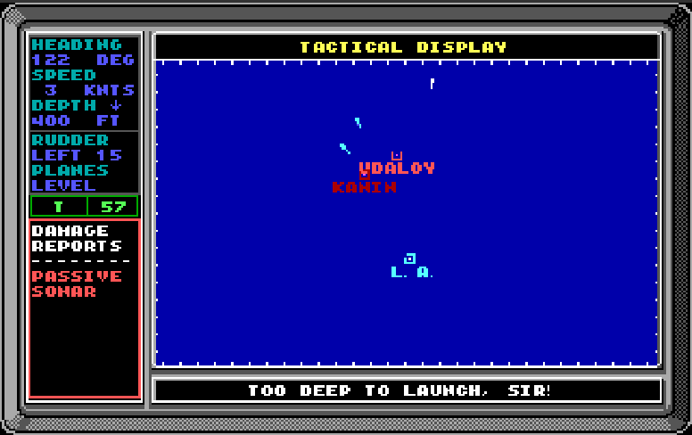
Above is a screen taken from the game. It includes a map showing the location of the submarine, enemies, torpedoes and missiles. On the left of the map is much vital information, on the upper half is information about the player’s submarine movement, and on the bottom-half is information pertaining to an enemy contact. Players may find such a screen especially useful as it is information dense without being overwhelming.
Tom Clancy's Red Storm Rising (PC/DOS) 1989, MicroProse
Games PC RED STORM RISING User Manual (manualmachine.com)

silent hunter 1 (1996)

This is another MS-DOS submarine game released in 1996. It is a more recent title than Red storm rising, and as such features better graphics and better quality of life features.
Silent Hunter 1 Content Review & Gameplay
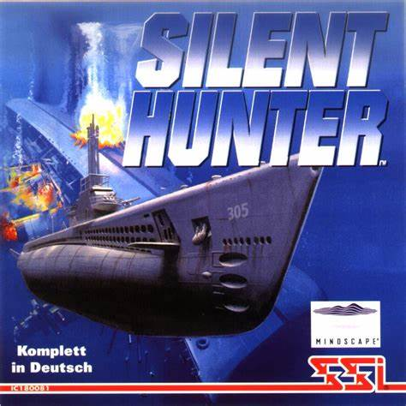

Some features I would like to take are the various screens filled with all sorts of dials containing large volumes of vital information, making the game slightly more challenging as you probe each screen for the information you want, and improves immersion. It also features a periscope view of the surface, which also would be interesting to add.

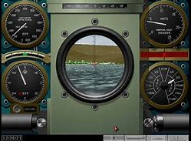
This a screen from the game showing the periscope view. It features a central periscope view and 4 gauges in either corner. These would be an interesting way to display information, adding to the tension of the game as you frantically try to read off the dials, but would be complex to add. The periscope view would require 3d graphics, which I am not using.

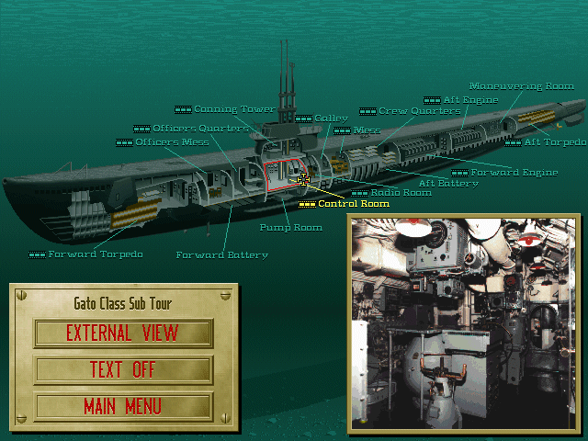
The above screen allows the player to travel around their submarine by selecting the section they want to be in. In my game, the player will only need to be in the control room issuing orders so this is also a feature that while would be nice, would not fit with my concept.

cold waters (2016)
Developed as a spiritual successor to Red storm rising, Cold waters is a modern take on the genre with modern graphics and QOL.
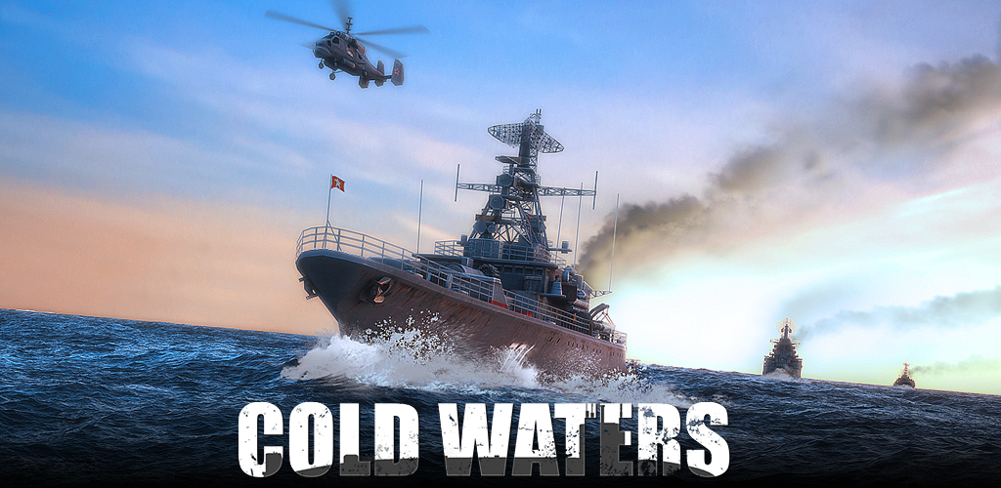
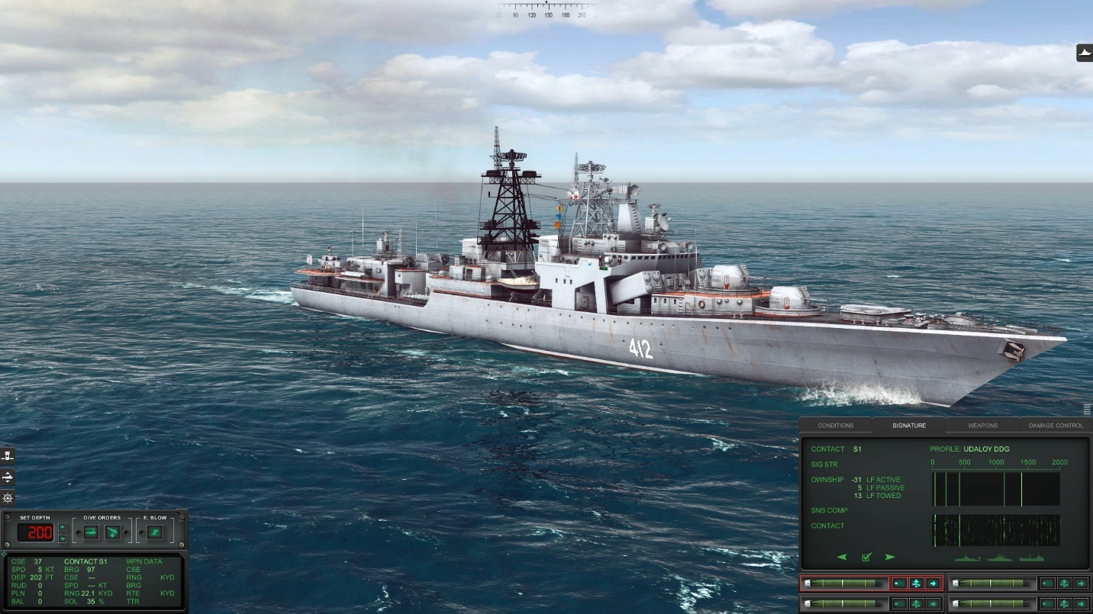
The graphics are far above anything I could achieve due to how relatively recent this game is compared to all others.

3.1.5 Requirements

Essential features
The Hunt for Blue November will be a real time tactics game where the player uses text commands to control their submarine and destroy enemy ships. An overview of the battlespace will be provided through a map screen, and the status of the player will be provided through a sensor screen.

Limitations
I am using python to create the game as it is the programming language I have the most experience in, but it is not ideal for game creation despite game engines for it existing. Graphics are limited, python is slow at best, and 3d is very difficult.

Hardware and Software
I will develop it on windows 10 so I am unsure of compatibility with other operating systems. It will need several python libraries. The game should not be graphically / computationally intensive so will not require powerful hardware but as python is not very efficient running through all ai every second may become mildly intensive.

Success criteria
The player can control the movement of their submarine through commands to change bearing, depth, and speed.
They will be able to fire weapons through commands to target enemy ships by either firing them in the general direction of an enemy if they are intelligent and self-homing weapons, or by specifying a target through their estimated location or code name assigned at detection.
The player will receive information through a map screen, sonar scope screen or sensor screen to determine their best course of action.
Enemy ships will attempt to find and destroy you through their ai which determines a course of action intelligently through information they receive. This will come in the form of movement and weapon firing.
There will be a map with depth values that a player can collide with if they are not careful.

ID | User Requirement | Evidence | Justification | Measurable Success Criteria (Testable)
1 | Command entry box | Project definition | Allows the user to input commands to control the submarine so they can play the game | - Game responds to input  pytho
2 | Map screen | Project definition | Map of surrounding enemies so that the player can know where the enemies are to attack them | - Window  - Icons representing player and enemies
3 | Sensor screen | Research | A screen with readings like speed, depth, ammo count so that the player can make choices such as conserving ammo and how likely they are to be detected | - Window  - Marked text based or graphical gauges
4 | Enemy ai | Project definition | Enemies change how they move or attack based on the player’s actions / movement so that the game is more engaging by having enemies that display intelligence | - Some enemies attempt to move in the direction of the player intentionally
5 | Homing Torpedoes | Project definition | Homing torpedoes fired by the player and enemies so that the player can kill enemies, and that enemies can pose a threat to the player | - Torpedoes track their targets and destroy them if a direct hit is scored
6 | Win screen | Research | If the player wins, they are told they have won along with their score so that the player gets feedback on how well they played | - Win screen  - score  - when all enemies defeated / objective completed
7 | Loss screen | Research | If the player wins, they are told they have lost so the player knows they need to practice more or read the instructions | - Loss screen when player dies
8 | Menu screen | Project definition | When the game is started, there should be a menu to play, see the controls, how to play and exit so the player can choose if they want to play and learn how to play | - Menu on startup  - options to play, get help or leave
Extension Success criteria
1 | Missiles | Project definition | Homing missiles fired by the player and enemies | - Missiles destroy a target when fired correctly
2 | Game world | Project definition | A height map to restrict the depth of the player’s submarine and have them evade underwater obstacles | - Terrain that can be crashed into if at low enough depth, causing game over
3 | Advanced ai | Stakeholder interview | To make the game even more strategic as the enemies would behave with far more intelligence | - Enemies respond to player actions with more precision
4 | Entity collisions | Research | Destroys any pair of vessels if they collide as would be realistic | - If two entities collide, destroy both

B. Design of the solution

3.2.1 Decompose the problem

structure

? – extension feature that may not be implemented due to time constraint

step by step
Main menu
Settings
Would allow the player to have some control over their experience but might take too much time to implement.
Game
Initialise game
Submarine?
Extension feature, allows the player to choose a submarine from a list with varying stats before starting the game
Weapons load?
Extension feature, allows the player to customizes their weapon load before starting the game
Difficulty?
Extension feature, allows the player to choose a difficulty before starting the game
Mission?
Extension feature, allows the player to choose the enemies they will face in game
Paused?
Game enters a paused state when enabled in-game
Un-pause
Resumes the game
Settings
Opens the settings menu
Main menu
Sends the player back to the main menu
Game loop
Manages the time every simulation cycle takes and the sub-algorithms required to run the game
Graphics
Sonar scope / map
Creates a window containing a map of the submarine’s surroundings
Event / kill feed
Logs whenever a major event occurs, such as the destruction of an enemy
Sound
Sound effects?
Extension feature, effects for detonations, engine sounds, etc
Music?
Extension feature, background music
Player
Inputs
A text box opened when a key is pressed to take inputs
Movement
The player can input speed / direction for the submarine, affecting factors such as noise generation
Attacks
The player can fire weapons. When fired, one weapon is removed from the player’s “inventory” and a weapon entity is spawned
Pause?
An extension feature where the player can press a key to enter the paused state
Ai
Vessel ai
Target
The ai decides which enemy is the most important to attack. As the player is the only enemy of the ship, this will decide whether the vessel’s sonar detects the player.
Movement
The ai decides at what speed and direction to move. If it is too far or close to its target, it will adjust accordingly. It may try to avoid enemy weapons as an extension
Attacks
The ai decides whether it is in an optimal position to use its weaponry against the player, and fire it if true. This removes one weapon from the inventory and spawns a weapon entity
Weapon ai
Target
The weapon (torpedo) will decide what it is trying to hit, which will be the closest target in its seeking field of view, regardless of if it is an enemy or friendly of the ship that fired it. If it cannot find any targets, it will self-destruct.
Movement
The weapon (torpedo) will decide the direction it needs to move in to hit its target and will update its position
Collision
The weapon (torpedo) will decide if it has hit its target, and destroy it if it has.
Database
Entities
Player
A csv file containing the player’s coordinates, weapon load, speed, direction, etc.
Vessels
A csv file containing the enemies’ coordinates, weapon load, speed, direction, etc.
Weapons
A csv file containing weapons’ coordinates, speed, direction, etc.
Constants
Vessel stats
A csv file containing vessels base stats such as weapon load, speed, turn rate, etc.
Weapon stats
A csv file containing weapon base stats such as speed, turn rate, damage etc.
End screen
Win / Loss
Displays whether the player won or lost the battle in large text to make the outcome clear to the player,
Action log?
A list of all actions taken by the player and enemies during the battle, such as movements, weapon launches, and kill feed
Main menu
Takes the player back to the main menu ui

Settings
Controls
A list of all the controls so players can double check. As an extension the controls could be customizable
Difficulty?
An extension feature to change the difficulty setting midgame, if I even implement difficulty settings in the first place.
Simulation speed?
An extension feature to change the speed of the simulation to have more thinking time or less waiting time
Tutorial?
An extension feature where an explanation of how to play the game is given, including tactics and other strategies
Video?
An extension feature to change game resolution, aspect ratio, etc
Audio?
An extension feature to change volume of various different sound effects

3.2.2 Describe the solution

Algorithms
Motion
The game operates in three dimensions so I will need algorithms that take inputs of direction, speed and current position to generate new positions for entities.
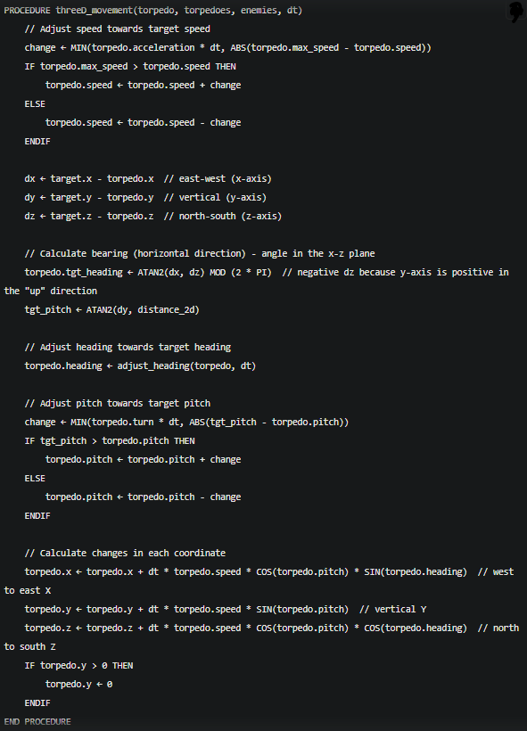
This algorithm will be used for torpedoes as they have a bearing and pitch so that they can point at their targets, as such they have the most complex maths.

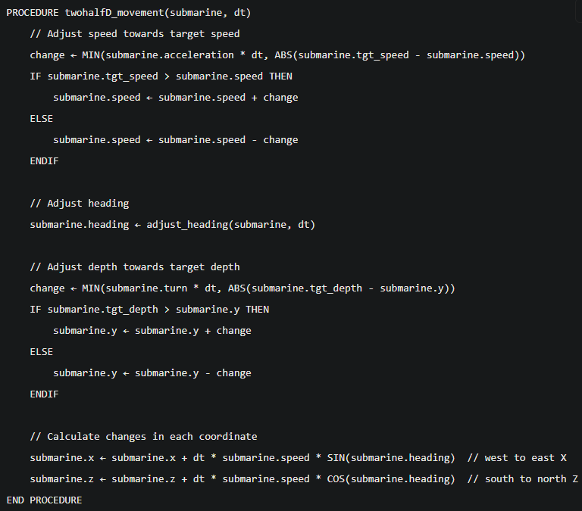
twohalfD_movement is used for the player’s submarine which will be able to move horizontally and vertically but with bearing only and no pitch and thus being simpler than the first algorithm

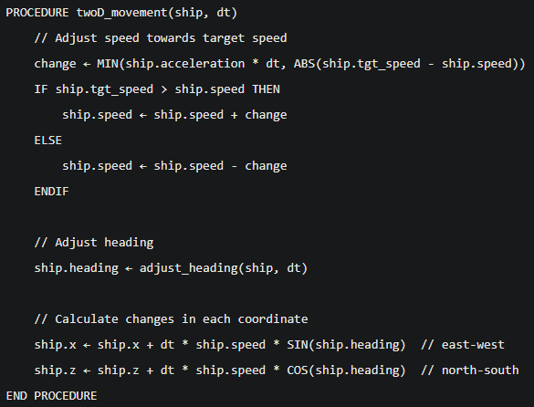
The final movement algorithm is for movement in a vertical plane with no vertical component at all. This will be used for enemy ships as they are unable to fly or dive.

Usability
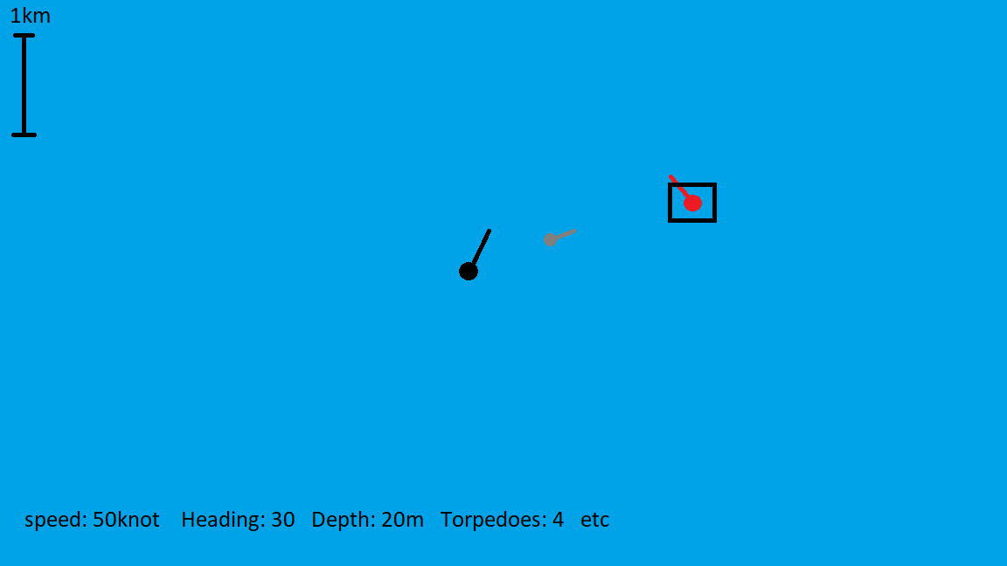
The interface will be rather simplistic, reflecting a digitally generated view rather than a realistic top down view. The design should be simple / intuitive to understand.
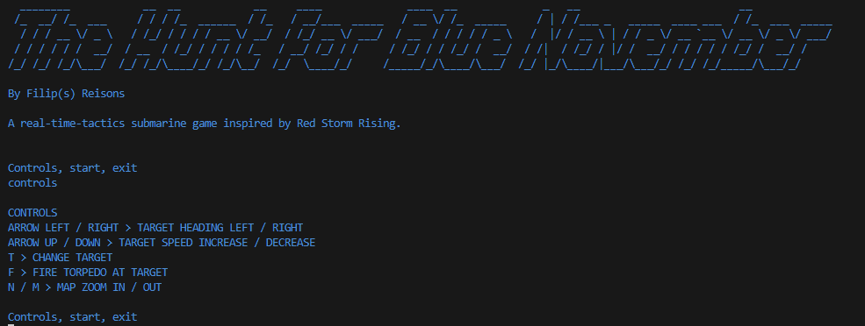
When launched, the game will open a command prompt window that allows the player to start the game or get help with keybinds or how to play.

Variables

Name | Type | Use | Need
dt | float | Storing the time between frames | To correctly time events and simulations irrespective of framerate
FPS | int | FPS limit | Limiting FPS
map_scale | int | Map size | Change the map size
player | object | Store player data | Have the player in game
Cooldown | float | Time between firing torpedoes | Limit the amount of torpedoes a player can fire per second
pause | bool | Store the game state
enemies | list | Store enemy instances | Have enemies in the game
torpedoes | list | Store torpedo instances | Allow the player to fire torpedoes
Enemy_torpedoes | list | Store enemy torpedo instances | Allow enemies to fire torpedoes

3.2.3 Describe the approach to testing

milestones

test data
Iterative white box
Post development black box

Testing during implementation

Testing post-production

Systems diagram

C. Developing the coded solution (“The development story”)

3.3.1 Iterative development process

DATE: 15/10/23
This project is going to be very math intensive due to the nature of three-dimensional motion. I have decided to create a set of general-purpose algorithms that will handle three-dimensional motion for all entities in the game, with variations of each algorithm depending on what each category of entities require. For each game tick, all entities will run through their respective motion algorithm to determine their new co-ordinates.
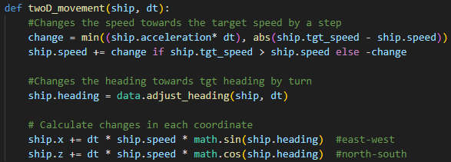

DATE: 21/10/23
After beginning to attempt to implement the original data storage method I had planned, I had realized that csv files were not going to be suitable. Despite the limitations of classes, I am going to have to use them instead as they are more suitable and I have more experience with them.

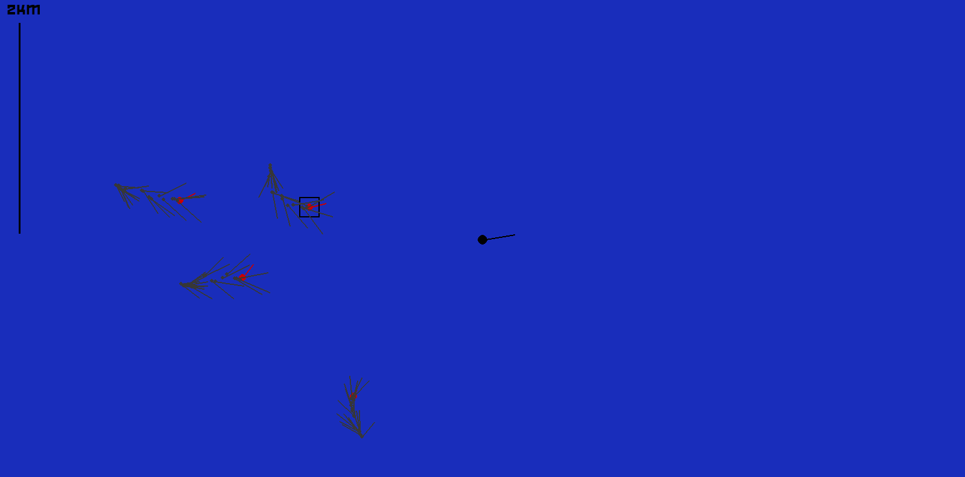

3.3.2 Testing to inform development

D. Evaluation

3.4.1 Testing to inform evaluation

3.4.2 Success of the solution

3.4.3 Describe the final product

3.4.4 Maintenance and development

Project Appendixes

Sources
This is all I have to give.
I’m sorry I didn’t do more.
I really did want to do more.
I tried to do more.
I don’t know why I didn’t.
Thank you for referring me to Tyler Day in room 37.
It was nice speaking to him.
But it seems I’ve been forgotten again.
You’ve been a wonderful teacher who tried his best to help.
I thank you for it.
Thank you, Sir.

